|  |
| --- |
|  |
| 新概念 3 册 |
| Lesson23 One man’s meat is another man’s poison |

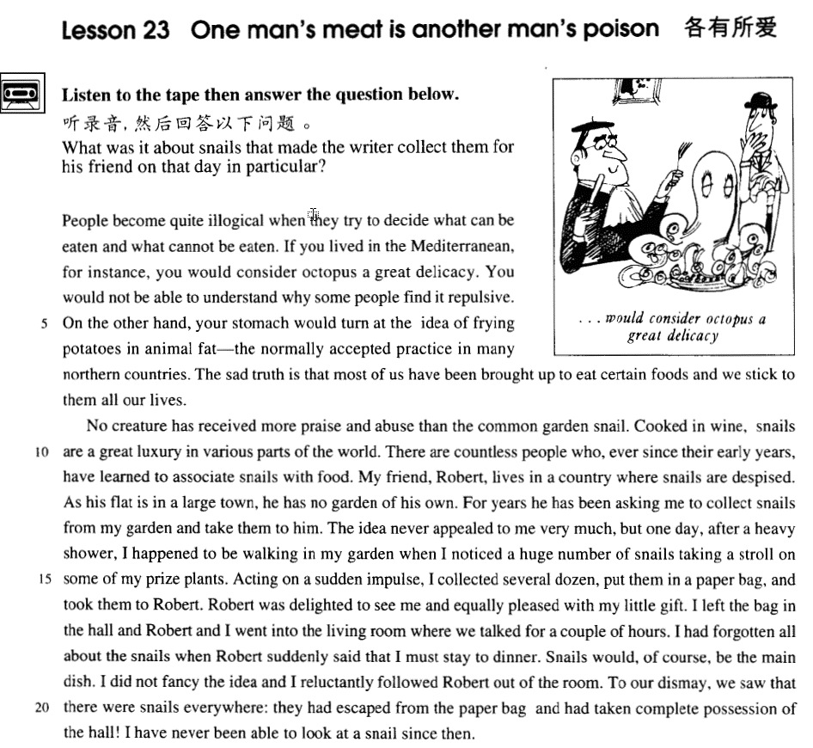

课文

People become quite illogical when they try to decide what can be eaten and what cannot be eaten.

在决定什么能吃而什么不能吃的时候，人们往往变得不合情理。

If you lived in the Mediterranean, for instance, you would consider octopus a great delicacy.

比如，如果你住在地中海地区，你会把章鱼视作是美味佳肴，

You would not be able to understand why some people find it repulsive.

你同时不能理解为什么有人一见章鱼就恶心。

On the other hand, your stomach would turn at the idea of frying potatoes in animal fat -- the normally accepted practice in many northern countries.

另一方面，你一想到动物油炸土豆就会反胃，但这在北方许多国家却是一种普通烹饪方法。

The sad truth is that most of us have been brought up to eat certain foods and we stick to them all our lives.

不无遗憾的是， 我们中的大部分人，生来就只吃某几种食品，而且一辈子都这样。

No creature has received more praise and abuse than the common garden snail.

没有一种生物所受到的赞美和厌恶会超过花园里常见的蜗牛了。

Cooked in wine, snails are a great luxury in various parts of the world.

蜗牛加酒烧煮后，便成了世界上许多地方的一道珍奇的名菜。

There are countless people who, ever since their early years, have learned to associate snails with food.

有不计其数的人们从小就知道蜗牛可做菜。

My friend, Robert, lives in a country where snails are despised.

但我的朋友罗伯特却住在一个厌恶蜗牛的国家中。

As his flat is in a large town, he has no garden of his own.

他住在大城市里的一所公寓里，没有自己的花园。

For years he has been asking me to collect snails from my garden and take them to him.

多年来，他一直让我把我园子里的蜗牛收集起来给他捎去。

The idea never appealed to me very much, but one day, after a heavy shower, I happened to be walking in my garden when I noticed a huge number of snails taking a stroll on some of my prize plants.

一开始，他的这一想法没有引起我多大兴趣。后来有一天，一场大雨后，我在花园里漫无目的散步，突然注意到许许多多蜗牛在我的一些心爱的花木上慢悠悠的蠕动着。

Acting on a sudden impulse, I collected several dozen, put them in a paper bag, and took them to Robert.

我一时冲动，逮了几十只，装进一只纸袋里，带着去找罗伯特。

Robert was delighted to see me and equally pleased with my little gift.

罗伯特见到我很高兴，对我的薄礼也感到满意。

I left the bag in the hall and Robert and I went into the living room where we talked for a couple of hours.

我把纸袋放在门厅里，与罗伯特一起进了起居室，在那里聊了好几个钟头。

I had forgotten all about the snails when Robert suddenly said that I must stay to dinner.

我把蜗牛的事已忘得一干二净，罗伯特突然提出一定要我留下来吃晚饭，这才提醒了我。

Snails would, of course, be the main dish.

蜗牛当然是道主菜。

I did not fancy the idea and I reluctantly followed Robert out of the room.

我并不喜欢这个主意，所以我勉强跟着罗伯特走进了起居室。

To our dismay, we saw that there were snails everywhere:

使我们惊愕的是门厅里到处爬满了蜗牛：

they had escaped from the paper bag and had taken complete possession of the hall!

它们从纸袋里逃了出来，爬得满厅都是！

I have never be able to look at a snail since then.

从那以后，我再也不能看一眼蜗牛了。

词汇讲解

* **poison** ['pɔizən] n. 毒药

**rat poison** 老鼠药

**poison gas** 毒气

**poison arrows** 毒箭

**one man’s meat is another man’s poison**(非常难吃的东西)

* The reader's hair stands on end when he reads in the final pages of the novel that the heroine, a dear old lady who had always been so kind to everybody, had, in her youth, poisoned（毒死） every one of her five husbands.
* **指环王**
* The ring brought to Gollum unnatural long life. For 500 years it **poisoned**（毒害） **his mind**.

**poisonous** ***adj.*** 有毒的；恶毒的；讨厌的

**toxic** ***adj.*** 有毒的；中毒的

**noxious** ***adj.*** 有害的；有毒的；败坏道德的；讨厌的

* Carbon monoxide is a colorless, odorless and **noxious** gas.
* **delicacy** ['delɪkəsɪ]n. 美味，佳肴

**delicious** ***adj.*** 美味的；可口的

**tasty** ***adj.*** 美味的；高雅的；有趣的

**luscious** ***adj.*** 甘美的；满足感官的

**yummy** ***n.*** 美味的东西；令人喜爱的东西

**yucky** ***adj.*** 恶心的；讨人厌的；不愉快的

* **repulsive** [ri'pʌlsɪv] adj. 令人厌恶的

**repulsive smell / behavior** 令人厌恶气味/行为

**repulse** ***vt.*** 拒绝；驱逐；憎恶

* The tourists were **repulsed** by the filthy conditions.

表达**“令人反感的”**相关词汇：

**repel** **repellent**

**revolt** **revolting**

**disgust** **disgusting**

* **turn [tɜ:n]** v. 感到恶心，翻胃

表达**“令人恶心的食物”**相关词汇：

* The food makes my stomach **turn**.
* The food **turns** my stomach.
* The food **disgusts** / **nauseates** / **sickens** me.
* The food **repels** / **revolts** my stomach.
* The food makes me **feel sick** / **lose my appetite**.
* The food makes me **throw up** / **vomit**.
* **fry** [fraɪ]v. 煎，炸
* I have another fish to **fry**（有事）.

**frying pan** 煎锅

* out of the frying pan into the fire fries 猜出龙潭，又入虎穴

**French fries** 炸薯条

* **口语**

**问：**

* May I take your order? 可以点菜了吗？
* What’ll it be for you? 要点什么

**答：**

* I need a double cheese burger, a **fries**, and a small coke.
* I need a No. 1 combo. 1号套餐
* For here or to go? 打包还是带走
* Here. / To go. 外带
* That’s five dollars and fifty cents. 一共五十分
* Here you are. / Here you go. 给你
* This is your change and receipt. 你的收据
* Can I have some ketchup? 番茄酱
* It’s on the service counter over there.
* Thank you!
* You’re welcome. Have a nice day!
* **associate** [ə'səʊʃɪeɪt] v. 联系；联想

**associate A with B** 把A和B联系起来

* We often **associate** wealth **with** happiness, yet this is not always the case.

表达“**把A和B联系起来**”动词表达:

**connect A with / to B**

**link A with / to B**

**relate A with / to B** (抽象的连接)

表达“**把A和B联系起来**”名词表达:

**make a connection between A and B**

**establish a link between A and B**

**establish a relationship between A and B**

* 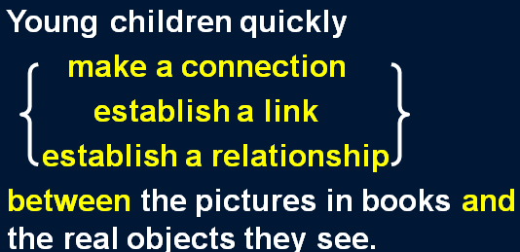
* **despise** [dɪ'spaɪz]v. 鄙视
* Do not **despise** your enemy.不能轻敌

表达**“鄙视”**相关词组:

**scorn** **…**

**hold** **…** **in** **contempt**

**look** **down** **on** / **upon** **…**

* **《围城》**英文版 — ‘Fortress besieged’ by Zhongshu Qian
* For in a university, science majors **look down on** humanities majors, foreign language majors **on** Chinese majors, Chinese majors **on** philosophy majors, philosophy majors **on** sociology majors, and sociology majors **on** education majors. Since education majors have no one to look down on, they can only **despise** the professors in their own department.

表达**“尊敬”**相关词组:

**respect** …

**esteem** …

**honor …**

**revere …**

**look up to …**

**hold … in high esteem**

* Because of their achievements they **were** **held** **in** **high** **esteem**.

课文讲解

# （题目）

# One man’s meat is another man’s poison.

习语：各有所爱

There’s no accounting for taste.

* **口语对话**

—Why did she marry someone like that?

—**One man’s meat is another man’s poison**. / **There’s no accounting for taste.**

# （第一段）

# People become quite illogical when they try to decide *what can be eaten* and *what cannot be eaten*.

* **课文写法替换：**
* People become quite illogical **when it comes to** （习语：**当说到/谈起/要做…的时候**）deciding what can be eaten and what **cannot**（**书面语用连写，正式表达**） be eaten.

# If you lived in the Mediterranean, *for instance*, you would consider octopus a great delicacy.

知识点（一）

**语法：**与现在事实相反的“if” 型的虚拟语气

**if + S. + did / were, S.**（主语） **+ would / should / could / might + do**

知识点（二）

**the Mediterranean** 地中海

**southern Europe** 南欧

**地中海的国家：**

**Italy**

**Spain**

**Greece**

…

表地区加定冠词“the”：

the Mediterranean

the Near East

the Middle East

the Far East

知识点（三）

表达**“比如说”**：

**for instance**

**for example**

**e.g.**

* **造句：**如果你住在北京，你就会把豆汁儿 (Douzhir) 当作一道美味佳肴。
* If you lived in Beijing, you would consider Douzhir a great delicacy.
* **造句：**如果你住在中国东北地区 (the Northeast of China), 你就会非常喜欢滑冰。
* If you lived in the Northeast of China, you would consider skating a great pleasure.

**such as** / **like** 举个例子

* People’s ability to do the test is influenced by factors **such as** / **like** age, sex, and ethnic background.

**take … for example** 以…为例

* **Take me for example,** I’ve never relied on other people for help.

**be a case in point** 很恰当的例子

* Lack of communication causes serious problems and their marriage **is a case in point.**

**by way of illustration** 举例来说

* Other countries have totally different laws on abortion. **By way of illustration** let us look at the cases of Germany and Japan.

**to name but a few** 仅举几例

* So many industries have been hit in the recession. Steel, coal, construction, **to name but a few.**

# You would not be able to understand why some people find it repulsive.

**… find it repellent** / **disgusting** / **revolting**. 令人厌恶的

# On the other hand, your stomach would turn at the idea of *frying potatoes in animal fat*—*the normally accepted practice in many northern countries*.

知识点（一）

**on the one hand ... on the other (hand)…** 【转折】一方面，但是另一方面 （一定用于相互矛盾的两个方面）

* **On the one hand** I'd like a job which pays more, **but on the other (hand)** I enjoy the work I'm doing at the moment.

**for one thing … for another …** 原因之一是…另一个原因是

* "Why won't you come to New York with me?"
* **"For one thing**, I don't like flying, **and** **for another,** I can't afford it."

**not that …, but that …** 不是因为…，而是因为…

* **Not that** I love Caesar less, **but that** I love Rome more. — Shakespeare ‘Julius Caesar’
* **Not that** I love you less, **but that** I love liberty more.
* **Not that** I love my teacher less, **but that** I love truth more. 吾爱吾师，吾更爱真理

知识点（二）

**at the … of …** 【时间状语短语】一…就

* She screamed **at the** sight **of** the ghost. 一看到就…
* She trembled **at the** thought **of** the murder. 一想到就…
* She fainted **at the** news **of** her father’s death. 一 获得（消息）就…
* She wept **at the** mention **of** the accident.一提到就…
* Most of my friends live in the city, yet they always go into raptures **at the** mere mention **of** the country.

知识点（三）

**practice**: custom / tradition 风俗/习惯

* **a bad practice** 不正之风

# The sad truth is that most of us have been brought up *to eat certain foods* and we stick to them all our lives.

知识点（一）

**sad**: **unfortunate** / **regrettable** 令人遗憾的

* He made a **sad** mistake.
* **老友记**
* I guess I set up the video camera to try and entice Joey.
* But **sadly** （遗憾的）I could not be enticed.

a **happy**（幸运的） discovery

**the happy few** 幸运的少数

知识点（二）

**bring up / raise sb.** 把…抚养大

* He was **brought up** / **raised** by his step-mother.

**be brought up to do** 从小就……

* We have **been brought up** to fear insects.
* **高考阅读真题：**
* I have **been brought up** **to** believe that it is proper to make contributions to charity.
* **六级阅读真题：**
* And perhaps all those successful college graduates would have been successful whether they had gone to college or not. This is heresy* to those of us who have **been brought up to** believe that if a little schooling is good, more has to be much better.

知识点（三）

**certain foods** 食物表种类可数

= **certain kinds of food**

知识点（四）

**stick to sth.** 维持，坚持

**keep to sth.**

知识点（五）

**all ones lives** 一生

**throughout our lives**

# （第二段）

# No creature has received more praise and abuse than the common garden snail.

知识点（一）

**receive + n.** 受到……；得到……；遭到……

* These young people, who love the peace of the mountains, always **receive** a warm welcome at St. Bernard’s monastery.

**receive** praise 得到表扬

**receive** abuse 遭到谩骂

**receive** support 得到支持

**receive** good education 收到良好教育

**receive** adequate* treatment 收到良好治疗

**receive** a warm welcome 收到欢迎

* This exhibition **received** a great deal of attention in the press, for though the pictures were supposed to be the work of famous artists, they had in fact been painted by Dickie.

知识点（二）

**语法：**否定词加比较词表达最高级的含义

* **Nothing** is **more** shameless than fooling the public.
* There is **no quicker** method of disposing of patients than by giving them what they are asking for.
* **Nothing** can be **compared**, he maintains*, with the first cockcrow, the twittering of birds at dawn, the sight of the rising sun glinting on the trees and pastures.
* But **nothing** can **match** them for **speed** and **comfort**.

# Cooked in wine, snails are a great luxury in various parts of the world.

表达**“在世界各地”**：

**in various parts of the world**

**all over the world**

**throughout the world**

**the world over**

# There are countless people who, ever since（介词） their early years, have learned to associate snails with food.

知识点（一）

**ever since** (介词，副词，连词)

* The big clock which used to strike the hours day and night was damaged many years ago and has been silent **ever** since. (副词)
* You know how she feels about you. It’s been the same way **ever since** （连词）we were kids.

知识点（二）

表达“把…联系起来”：

… have learned to **connect** snails **with** / **to** food.

… have learned to **link** snails **with** / **to** food.

… have learned to **relate** snails **with** / **to** food.

… have **made a connection between** snails **and** food.

… have **established a link between** snails **and** food.

… have **established a relationship between** snails **and** food.

# My friend, Robert, lives in a country where snails are despised.

# As his flat is in a large town, he has no garden of his own.

**… of one’s own** （名词后，后置定语）某人自己的……

* …, but they lead mysterious lives **of their own** as well.
* …, he has no **private / personal** （前置定语）garden.

# For years he has been asking me to collect snails from my garden and take them to him.

**collect**: gather 收集

* Gather rose-buds while you may.

# The idea never appealed to me very much, but one day, *after a heavy shower*, I happened to be walking in my garden when I noticed a huge number of snails *taking a stroll on some of my prize plants*.

知识点（一）

**appeal to sb.** 吸引某人

* The quiet life of the country has never **appealed to me**.
* In spite of national differences, certain funny situations have a universal **appeal**.

**appeal (to sb.) for sth.** 恳求某人某事

* They are **appealing to local businesses for sponsorship**.
* As the crisis grew worse, the government **appealed for unity.**

**an appeal for** help / food / extra staff … 呼吁

知识点（二）

**happen to do** 碰巧发生

* It's missing head h**appened to be** among remains of the fifth century B.C.

知识点（三）

**语法：**主句 (进行时 / be about to do) + when ... “when”应译为“这时”或“突然”

* I **was having** dinner **when** the phone rang.
* I **was about to leave** **when** the phone rang.
* He **was still mumbling** something about hospitals at the end of the party when he slipped on a piece of ice and broke his left leg.
* The Karen had **been sailing** in a convoy to Russia when she was torpedoed by an enemy submarine.
* The morning passed rapidly and Frank **was about to leave** **when** he noticed a large packing case lying on the floor.

知识点（四）

**take a stroll / walk** 散步

知识点（五）

**prize**: valued / treasured （对某人有特殊意义，本身并不一定值钱）心爱的，珍贵的

* One of Mary's **prize** possessions was a little white lamb which her husband had given her.

# Acting on a sudden impulse, I *collected* several dozen, *put* them in a paper bag, and *took* them to Robert.

**写作：**连续使用动词，表达一种迫切的情形

* George took off his jacket, rolled up his sleeves and pushed his right arm through the drain cover.

# Robert was delighted to see me and equally pleased with my little gift.

**delighted**: very pleased 非常开心，非常满意

**be delighted / pleased + with … / to do …** 非常开心的做某事

* I **felt** especially **pleased with** my wonderful bargain―until I got back to the ship.
* But I **was** extremely **pleased with** myself I had traced the cause of the trouble.
* When I was a teenager, I felt that I was just young and uncertain―that I was a new boy in a huge school, and I would have been very **pleased to be** regarded as something so interesting as a problem.

# I left the bag in the hall and Robert and I went into the living room where we talked for a couple of hours.

知识点（一）

Having left the bag in the hall, ???

* **课后题：**

7. Having left the bag in the hall, ___A___ into the living room. (11.16-17)

(a) **I accompanied Robert** (b) Robert took me

(c) we went (d) I and Robert went

知识点（二）

**语法：**形势的定语从句

Robert and I went into the living room **where** we talked for a couple of hours.

Robert and I went into the living room and we talked for a couple of hours *there*.

知识点（三）

a couple of hours. 两个小时左右

表达**“大约…”**时间：

**about** 2 hours

**nearly 2 hours**

**roughly 2 hours**

**some 2 hours**

**approximately** 2 hours

2 hours **or so**

**some 用法：**

some+不可数名词：一些；some water 一些水

some+可数名词复数：一些；some people 一些人

some+可数名词单数：一些；some person 某一个

some+数量词：大约；some one hundred people 大约100人

* **课后题：**

11. I went into the living room where we talked for___B___ (1. 17)

(a) round the clock ( b ) **two hours or so** (c) a second hour (d) some hours

# I had forgotten all about the snails when Robert suddenly said that I must stay to dinner.

知识点（一）

***should 型虚拟语气***

… when Robert suddenly proposed that I ***(should) stay* to** dinner.

知识点（二）

**stay** **to** / **for** **+ 三餐名** 留下吃饭

* Won’t you **stay to / for dinner**?

# Snails would, of course, be the main dish.

**main** **dish** / **course** 主菜

# I did not fancy the idea and I reluctantly followed Robert out of the room.

**课文写法替换：**

* … and I **unwillingly** followed Robert out of the room.
* … and I followed Robert out of the room with **reluctance**.

# *To our dismay*, we saw that there were snails everywhere: they had escaped from the paper bag and had taken complete possession of the hall!

知识点（一）

**dismay** 既惊讶又沮丧

* Imagine their dismay when they found a beautifully-cooked wallet and notes turned to ash!

知识点（二）

**take possession of … 占据……**

**be in possession of … 拥有……**

# I have never be able to look at a snail since then.

Once bitten, twice shy. 一朝被蛇咬，十年怕井绳